

FURTHER MATHEMATICS
TRIAL EXAMINATION 1
SOLUTIONS
2005

_____________________________________________________________________

Section A Section B – answers
answers

Core Module 1 Module 2 Module 3 Module 4 Module 5

1. C Arithmetic Geometry Graphs Business Networks
2. B and and and related and
3. A applications trigonometry relations mathematics decision
4. D maths
5. C 1. D 1. A 1. E 1. C 1. B
6. A 2. A 2. C 2. C 2. C 2. D
7. B 3. B 3. B 3. E 3. B 3. A
8. D 4. D 4. D 4. D 4. A 4. C
9. E 5. D 5. C 5. D 5. C 5. E
10. B 6. C 6. C 6. A 6. B 6. A
11. E 7. C 7. D 7. E 7. E 7. A
12. D 8. E 8. E 8. C 8. D 8. C
13. E 9. D 9. E 9. D 9. D 9. D
___________________________________________________________________________

Section A: Core - solutions

Question 1

The data trails off to the right so the data is positively skewed.
The answer is C.

Question 2

The median is the middle piece of data when all the data is in order. There are 34 pieces of data. The median of the data is half way between the 17th and 18th piece of data. This will lie in the $500 - $600 a week range.
The answer is B.

Question 3

There are 5 people who earn $800 or more.
The percentage is therefore 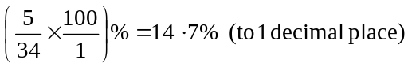
The answer is A.

Question 4

The mean mark is given by
The answer is D.

Question 5

The distribution of weights is bell shaped with a mean of 250g and a standard deviation of 3g.
Therefore we know that
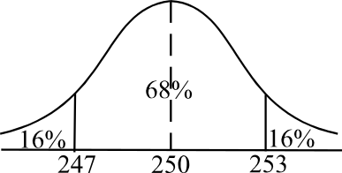
68% of weights will lie between
one standard deviation either side
of the mean; that is, between 247g and 253g.
By symmetry, 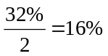 of weights must lie
below 247g and 16% must lie above 253g.
The answer is C.

Question 6

Enter the number of occupants in 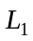 and the frequency in 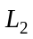then do 1-Var stats 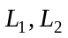.
The standard deviation for this data is 1.6 (to one decimal place).
The answer is A.

Question 7

There is a moderate to strong linear relationship and the relationship is also a negative relationship; that is as x increases, y decreases. The best answer is B.
The answer is B.

Question 8
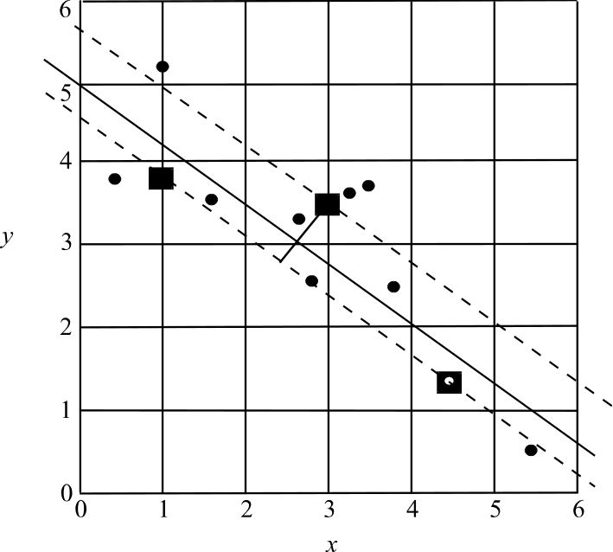

There are 10 pieces of data. Divide them into 3 pieces on the left, 4 in the middle and 3 on the right. The median of each of these groups is shown as a square on the diagram above. Place a ruler on the outside squares and move the ruler about one-third of the distance towards the middle square. Draw the 3-median regression line. It passes through the y-axis at approximately 5.
The answer is D.

Question 9

The two variables are the age when the person caught chickenpox and gender.
Age is a numerical variable and gender is a categorical variable.
The answer is E.

Question 10

The median age of males who had the disease was 5 whereas for females it was 10. Option B is incorrect.
The answer is B.

Question 11

To linearise the data we need to compress the x-scale in which case we could use a 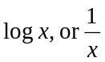 transformation. Alternatively we could expand the y-scale in which case we could use a 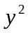 transformation.
We have therefore 3 transformations that we could choose.
Only option E offers two of these three.
The answer is E.

Question 12

When a residual plot appears to be a random collection of points that are approximately spread around zero, then the relationship between the two variables on the original scatterplot; in this case, age and score, is probably linear.
The answer is D.

Question 13

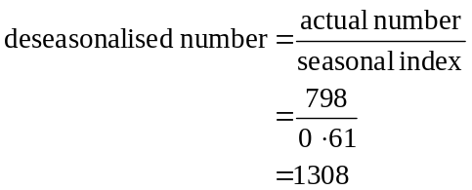
The answer is E.

Module 1: Number patterns and applications

Question 1

We have an arithmetic sequence since .
So, 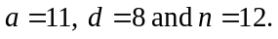
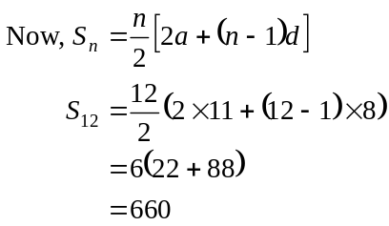
The answer is D.

Question 2

There are 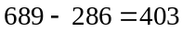 women attending the lecture.
The ratio of men to women is
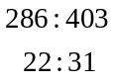
The answer is A.

Question 3

The difference between the second and the fourth term is 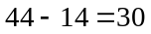 So the difference between the second and the third term is 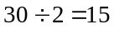. Therefore the difference between the first and the second term is 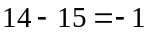.
The answer is B.

Question 4

A geometric sequence must have a common ratio, r.
For option A 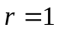, for option B it is 7, for option C it is –2 and for option E it is 0.01.
Option D does not have a common ratio, that is, 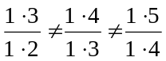.
The answer is D.

Question 5

We have a geometric sequence since enrolments increase by 7% each year.
In 2001, there were 342 enrolments so 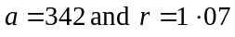 since each year enrolments increase by 7%. For 2001, n = 1 and so for 2005, n = 5
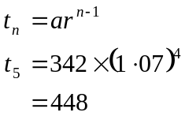
The answer is D.
Question 6
The depths they dig each day form a geometric sequence.
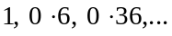
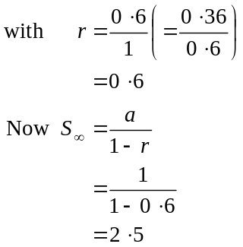
The answer is C.

Question 7

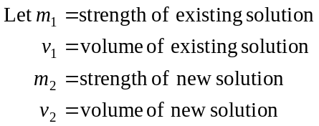
Now 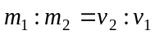, that is, as the volume of a mixture increases, the strength of the mixture decreases.
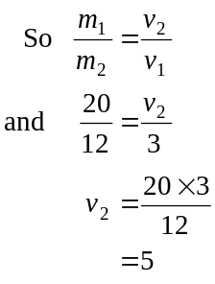
So 2 litres of water should be added to the existing 3 litres to create 5 litres.
The answer is C.

Question 8
The difference equation defines a geometric sequence since each term is generated by multiplying the previous term by 2.
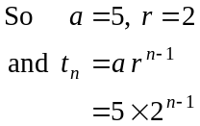
The answer is E.

Question 9
Each year 8% interest is paid on the money which is already in the account and then, another $2000 is added in.
So 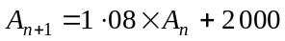
The order of operations we have in mathematics, whereby you perform the multiplication first and then the addition, ensures that the order of events is followed, i.e. calculate interest and then add some more to the account (this ‘added in’ amount doesn’t earn interest until next year).
The starting amount is 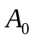 which is $5 000.
The answer is
The answer is D.
Module 2: Geometry and trigonometry

Question 1

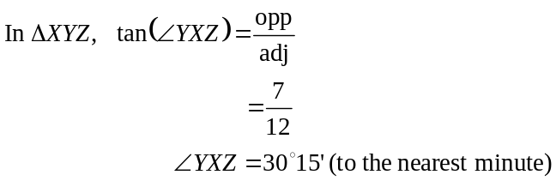
The closest answer is 30°.
The answer is A.

Question 2

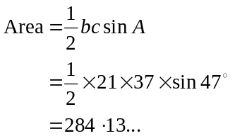
The answer is C.

Question 3

Use the sine rule.
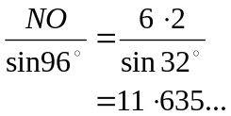
The closest answer is 11.6 km.
The answer is B.

Question 4

Let the sidelength of the smaller cube be x. Therefore the sidelength of the larger cube is 2x. So the volume of the cubes is 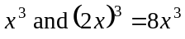 respectively.
The ratio of the volume of the smaller cube to the larger cube is 1:8.
The answer is D.

Question 5
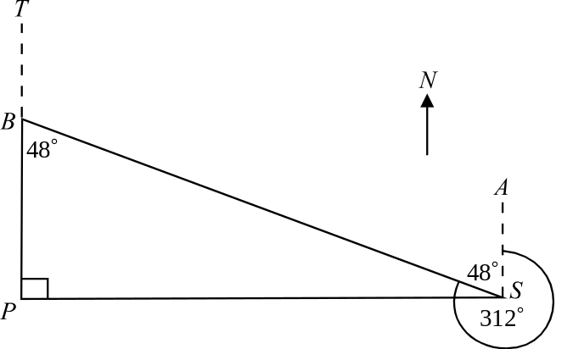

Since B is due north of P and S is due east of P, 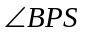 is a right angle.
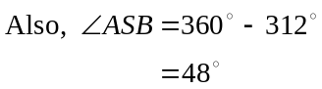
So 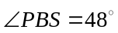 (Alternate angles in parallel lines are equal.)
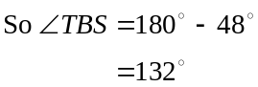
The bearing of S from B is 132°.
The answer is C.

Question 6

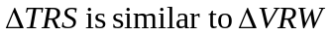.
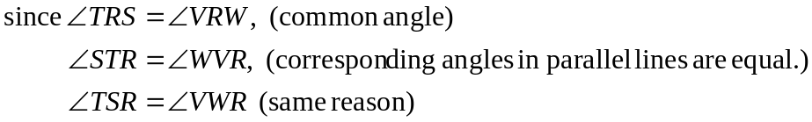
Triangles are similar; Angle, Angle, Angle.
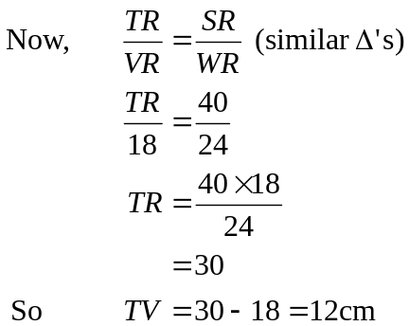
The answer is C.

Question 7

The contour lines join points that have the same altitude. If the contours are close together, the altitude (or height) of the hill is rapidly increasing, i.e. it’s steep. Conversely when the contour lines are further apart the hill is not as steep. The section on the line AF where the contour lines are furthest apart is DE. This is the least steep part along the line AF.
The answer is D.

Question 8

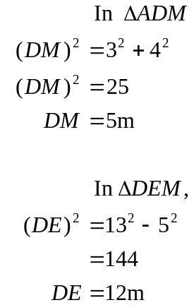
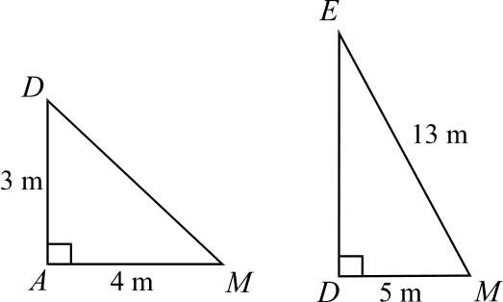
The height is 12m.
The answer is E.

Question 9
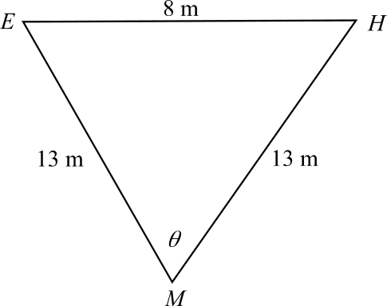
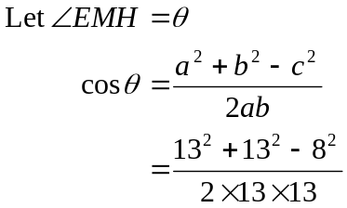
The answer is E.

Module 3: Graphs and relations

Question 1

Between 8am and 8pm during the second 24 hour period, the temperature was 25°C or over. In total therefore it was 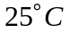 or over for a period of 12 hours.
The answer is E.

Question 2

In the first 24 hour period the maximum temperature occurred at 4pm. In the second 24 hour period the maximum temperature occurred very close to 12 noon.
The time that elapsed in between is therefore closest to 20 hours.
The answer is C.

Question 3

Hartmut’s connection lasted 32 minutes and cost $4.
Steffi’s connection lasted 20 minutes and cost $3.
The combined cost was $7.
The answer is E.

Question 4
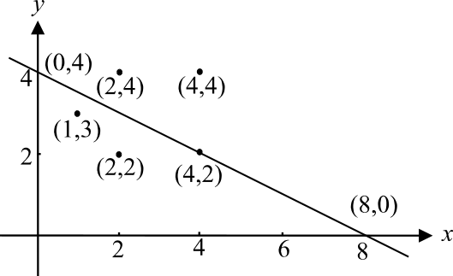

The point 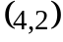 looks correct.
To check, the gradient of the line is given by
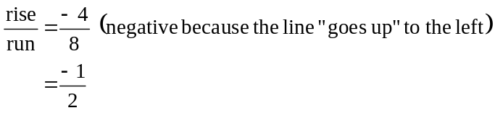
The y-intercept is 4.
The equation is 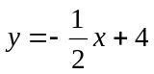.
Substitute into this.
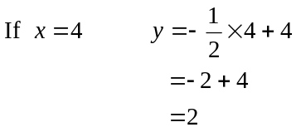
This is the correct point.
The answer is D.

Question 5

Running along ST, the constraint is 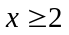, running along TU the constraint is 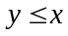 since the border has equation 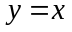 (gradient of 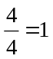 and y-intercept of 0).
Running along UV, the constraint is 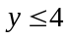, running along VW the constraint is 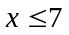, running along WY the constraint is 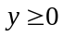 and running along SY, the constraint is 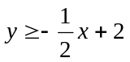 (gradient of 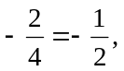 and y-intercept of 2).
The constraint that is not one of these is 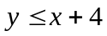.
The answer is D.

Question 6

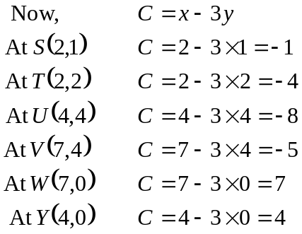
The minimum of –8 occurs at U.
The answer is A.

Question 7

Now, 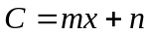
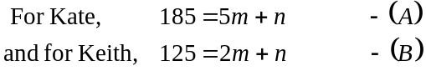
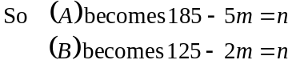
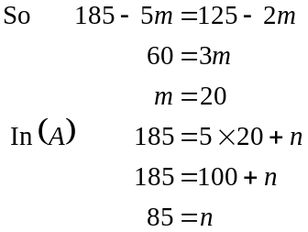
The sitting fee charged is $85.
The answer is E.

Question 8

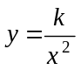 where k is a constant and is the gradient of the straight line.
Now, gradient 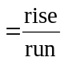
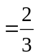
So, 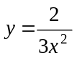
The answer is C.

Question 9

Bill works a maximum of 50 hours per week and Wally can work up to 10
hours per week so there is a maximum of 60 hours that can be worked by the pair.
Therefore 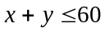.
For the window cleaning business, Bill works up to 20 hours and Wally can work up to 10 so there is a maximum of 30 hours that can be spent cleaning windows.
Therefore 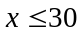.
For the gardening business, Bill works at least 15 hours.
Therefore 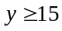.
The constraints are therefore 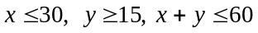
The answer is D.

Module 4: Business-related mathematics

Question 1
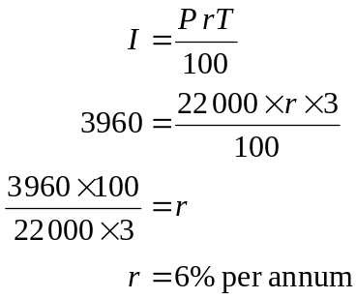
The answer is C.

Question 2

The annual rate of interest is 8%, so the quarterly rate of interest is 2%.
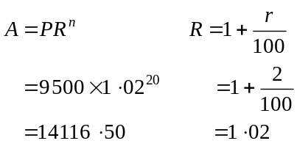
The answer is C.

Question 3

The car will be traded when it has depreciated by 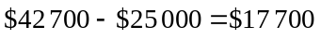.
Now
So it will be driven 84 286km before it is traded.
The answer is B.

Question 4

At the end of the fourth year the investment is worth
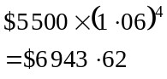
At the end of the fifth year the investment is worth
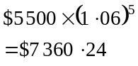
During the fifth year of the investment the amount of interest earned is 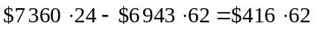
The answer is A.

Question 5

The amount in the account goes up each 6 months by an increasing amount. This eliminates options A and B since if simple interest is calculated on the original sum and added, it is the same amount added each 6 months.
Option D is not possible because the amount increases each 6 months not each year. Similarly, option E is not correct.
Option C is correct.
The answer is C.

Question 6

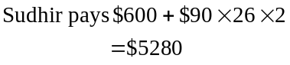
The retail price is $4300.
The total interest that Sudhir pays is 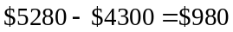.
The answer is B.

Question 7

The annual flat rate of interest Sudhir is being charged is 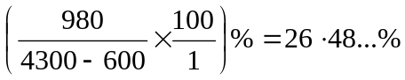.
The effective rate of interest is
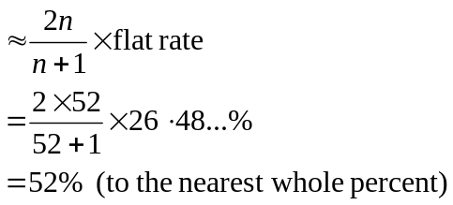
The answer is E.

Question 8

Since regular repayments are made, we use the annuities formula. The interest rate per month is 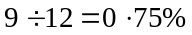.
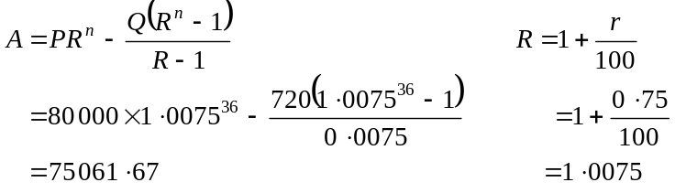
The answer is D.

Question 9

Use the annuities formula
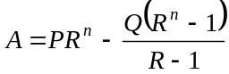
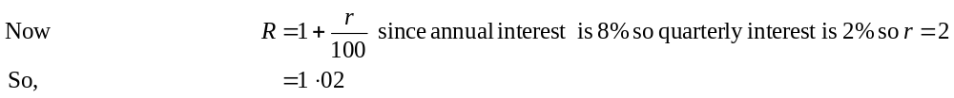The loan is fully paid off when 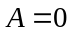; that is, when the amount still owing is zero.
So we have

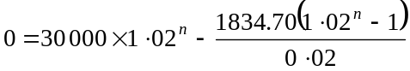

We need to find the value of n.

Method 1
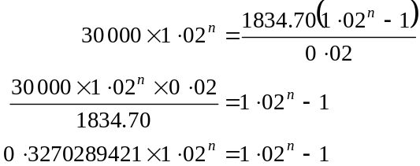

Try
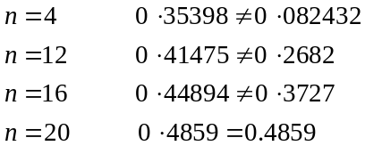
It takes 20 quarters or 5 years.
The answer is D.

Method 2
Graph the function 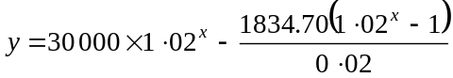 and find the value of x(or n) when a zero occurs. That value is 20.

The answer is D.

Module 5: Network and decision mathematics

Question 1

Since the graph is connected and planar we can use Euler’s formula 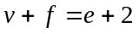
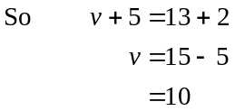
There are 10 vertices.
The answer is B.

Question 2
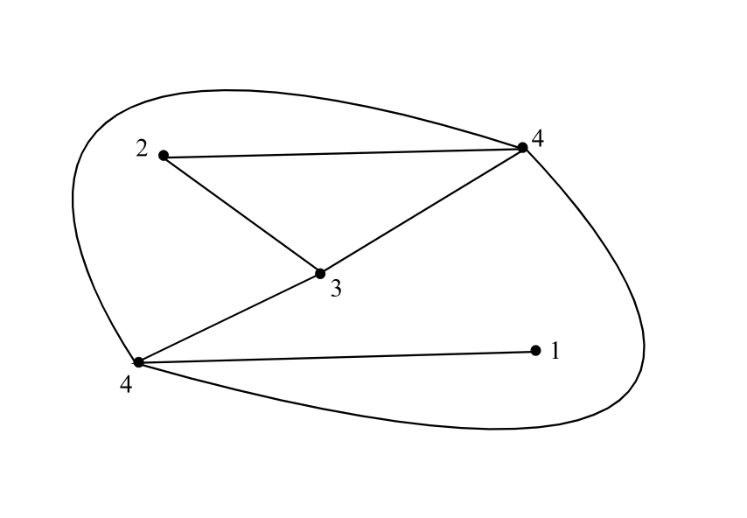

The sum of the degrees is 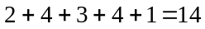.
The answer is D.

Question 3

A Hamiltonian path passes through each vertex just once.
The answer is A.

Question 4

Kate can play GS, WA or C. All options cover this.

Sue can play WA or C. This eliminates option A.

Brianna can play C or WD. This eliminates option E.

Alyssa can play WA, C or WD. This eliminates options B and D.

Meg can play C or GD. This eliminates option B.

Only option C is possible.
The answer is C.

Question 5

There is one vertex from A to B, B to C, C to D, C to E, D to E and A to D. Only option E shows this. Note that options C and D show only “one way connections”; that is, from A to B but not from B to A and vice-versa.. Matrix E is symmetrical about the diagonal.
The answer is E.

Question 6

The Hungarian algorithm can be used to solve this.
 | A | B | C | D
1 | 3 | 2 | 1 | 2
2 | 4 | 2 | 3 | 5
3 | 2 | 3 | 4 | 2
4 | 3 | 3 | 4 | 4
Step 1 – subtract the minimum number in each row from the other numbers in that row.
 | A | B | C | D
1 | 2 | 1 | 0 | 1
2 | 2 | 0 | 1 | 3
3 | 0 | 1 | 2 | 0
4 | 0 | 0 | 1 | 1
Step 2 – rows 1 and 2 contain only 1 zero. Box them and cross out the other zeros in the column.
 | A | B | C | D
1 | 2 | 1 | 0 | 1
2 | 2 | 0 | 1 | 3
3 | 0 | 1 | 2 | 0
4 | 0 | 0 | 1 | 1
Step 3 – row 4 contains only 1 zero. Box it and cross out the other zeros in the column.
 | A | B | C | D
1 | 2 | 1 | 0 | 1
2 | 2 | 0 | 1 | 3
3 | 0 | 1 | 2 | 0
4 | 0 | 0 | 1 | 1
The allocation is complete.
For minimum cost, printer A should do job 4, printer B does job 2, printer C does job 1,and printer D does job 3.
The answer is A.

Question 7

We need to find the cut with the minimum total. The various cuts across the network are shown in the diagram below.
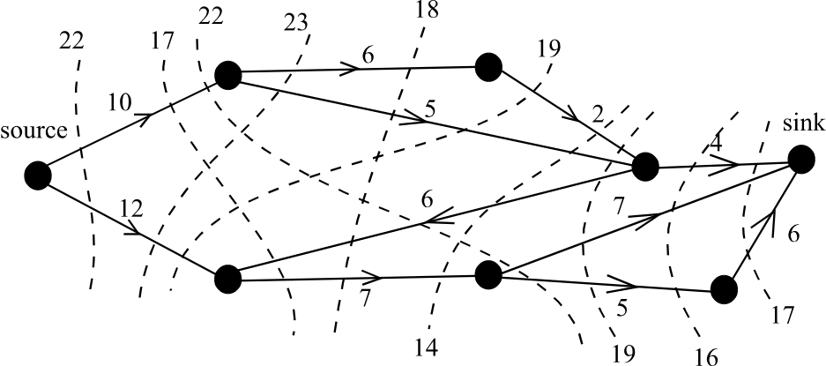

The minimum cut is 14. Note that the direction of the vertex with weight 6 is against the flow of the network (i.e. from source to sink) so the 6 is not counted in the total.
The maximum flow is therefore 14.
The answer is A.

Question 8

On the diagram below the earliest and latest start times are shown respectively above each vertex.
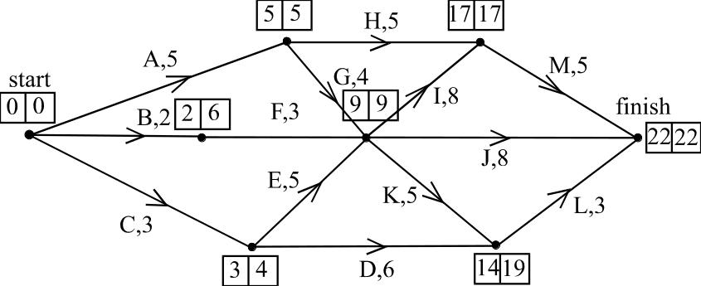

The critical path is A, G, I, M.
The answer is C.

Question 9

We are looking for the slack or float time of these activities.
Since activity A lies on the critical path its slack or float time is 0.
For B, the slack or float time is given by 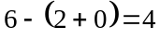.
For C, the slack or float time is given by 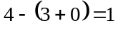.
For D, the slack or float time is given by 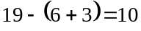.
For E, the slack or float time is given by 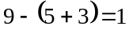.
The activity that can be delayed the longest is D since it has the most slack at float time.
The answer is D.

